# CS 340 README Template

## About the Project/Project Title

*This application will allow a user to access a database of animals at Austin Animal Shelter (AAC). It allows the user to search and filter a database of animals. The user searches using a filter for animals to create a dashboard. This also includes geolocation mapping and charts to locate and use animals for search and rescue.*

## Motivation

*This project exists to organize and read data from an animal shelter’s stored animal database. It is designed to work with databases and manipulate the data inside of them.*

## Getting Started

*To utilize this program you would follow these steps:*

1. *Enter Mongo*
2. *Import the csv file (aac_shelter_outcome.csv)*
3. *Create a simple and complex index to parse the data in the document*
4. *Authenticate the user by creating an admin account and an aacuser account*
5. *Use Python to run the program*
6. *Connect to the address*

## Installation

* *MongoDB to access the database*
* *Python to run the python and test files*

## Usage

*Use this space to show useful examples of how your project works and how it can be used. Be sure to include examples of your code, tests, and screenshots.*

### Code Example

*The code was unable to be run due to authentication issues.*

### Screenshots

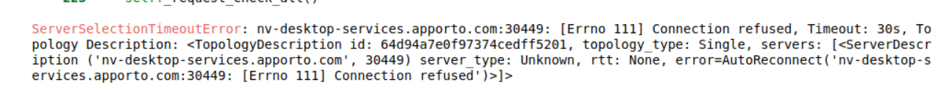

## Contact

Your name: Jenna Case